TC05 & TC06

TC05 :

**Test Scenario:** ESS User able to edit Personal details

**Test Case Title:** Verify ESS is able to edit personal details

**Test Case Steps:**

1) Launch bowser

2) Login to OrangeHRM web portal

3) Click on My Info

4) Click on Personal detail

5) Edit personal details

6) Click on save button.

**Let’s take default details screenshot first so that we can check later whether we were able to change/edit personal details or not :**

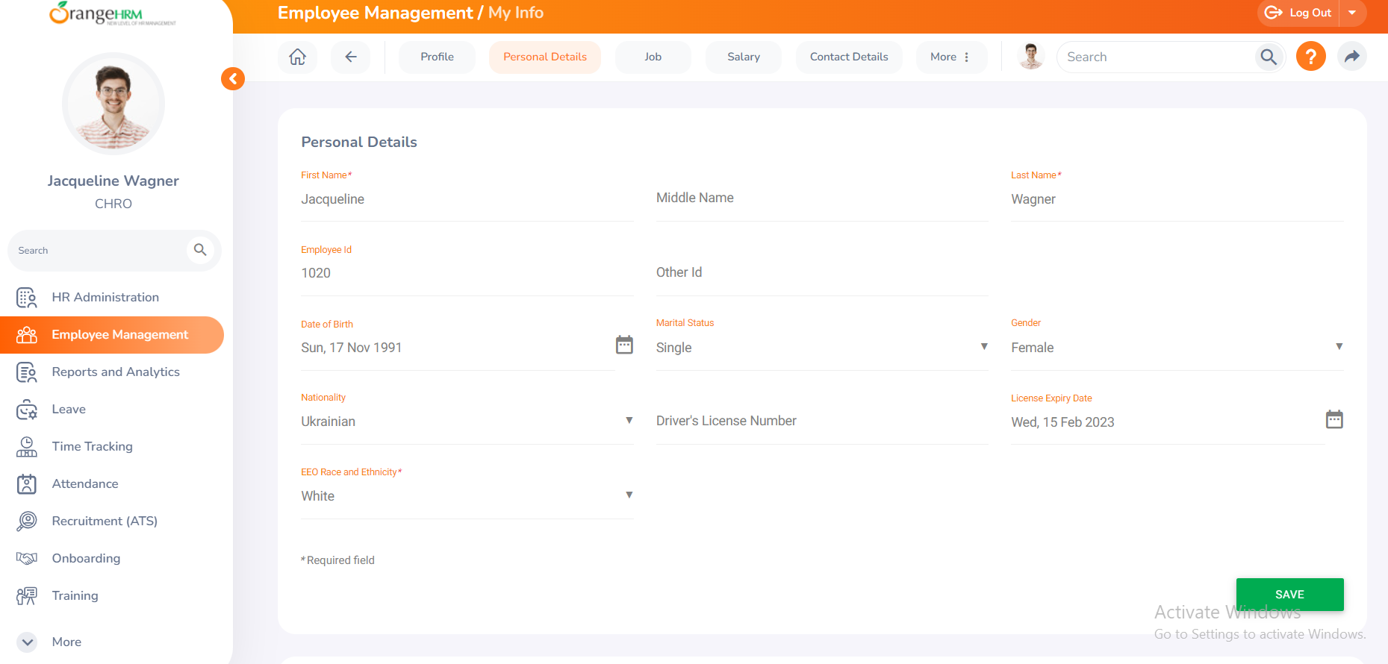

**Let’s edit personal details now :**

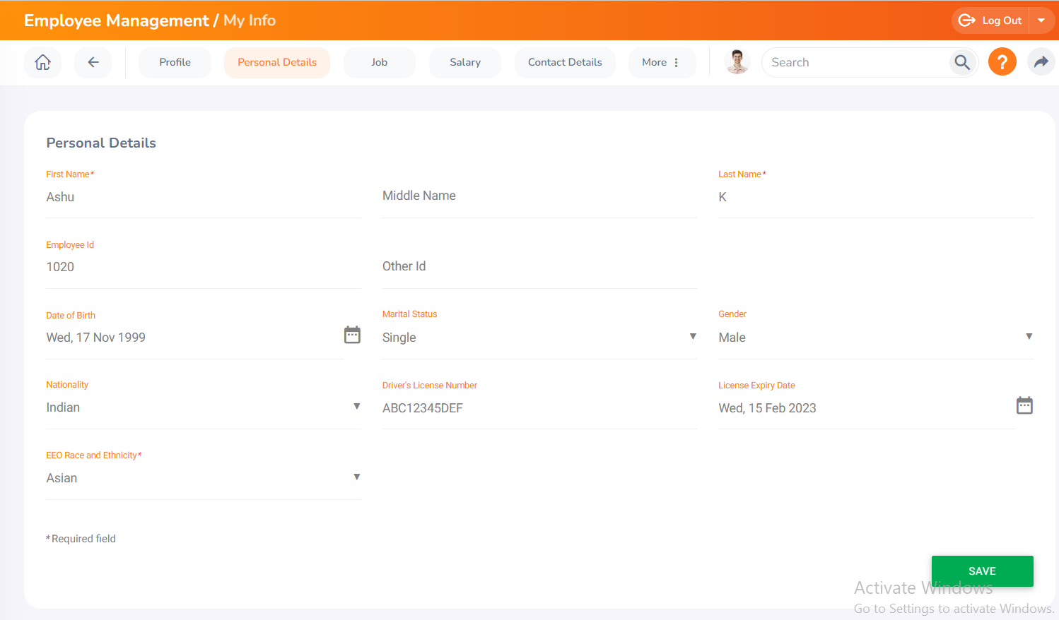

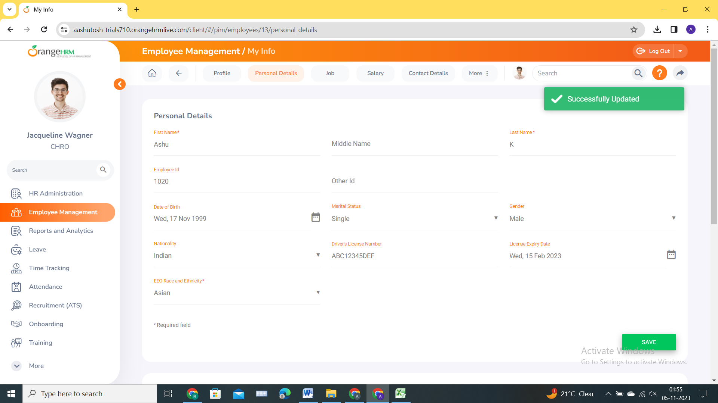

**TC06 :**

**Test Scenario:** ESS User able to Add attachments in Personal details

**Test Case Title:** Verify ESS is able to add attachments under personal details

**Test Case Steps:**

**1) Launch bowser**

**2) Login to OrangeHRM web portal**

**3) Click on My Info**

**4) Click on Personal detail**

**5) Add Attachments under personal details.**

**6) Click on save button.**

**Let’s add attachment as well :**



